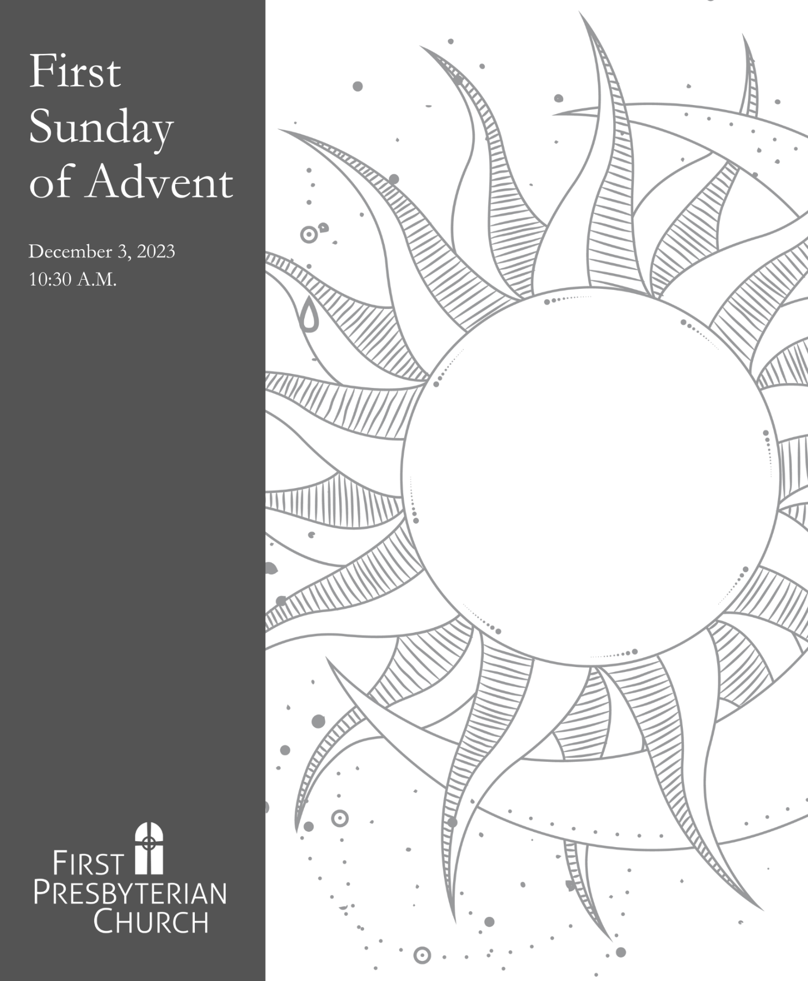
Service for the Lord’s Day

THE GATHERING

Prelude

Welcome & Announcements
The Lord be with you. And also with you.

Choral Introit “Prepare Ye the Way of the Lord” from Godspell Stephen Schwartz
Tevin Vincent, Baritone

Lighting of the Advent Wreath Ashley, Corey, Arlo, Claudia, and Sylvie Johnson We are waiting for the dawn of God’s incarnation.
Restore us, O God. Let us see your face.
We are like clay awaiting the potter.
Restore us, O God. Let us see your face.
Teach us to keep alert as we wait.
Restore us, O God. Let us see your face.
Sustain us this day as we worship you.
Amen.

As the first Advent candle is lit, all sing this refrain (hymn #90) three times through:
Wait for the Lord, whose day is near.
Wait for the Lord, be strong; take heart!

Great God, no one knows the hour of your return, yet we await your arrival, trusting that it will come. There is a sense of urgency in our waiting. We await the birth of Jesus, but we watch for so much more, anticipating all that your incarnation means in a hurting world. Teach us to keep alert, that we may not become complacent or convinced that we have time. Show us how to hurry up and wait, to enact our expectation by sharing love, offering forgiveness, and living according to the movement of the Holy Spirit. In the name of Jesus, we pray. Amen.

*Hymn 82 Come, Thou Long Expected Jesus HYFRYDOL
Time With Young Disciples Diane Bowers
May God be with you in worship here.
May God be with you in worship there.

Children may depart the sanctuary with their teacher for Worship & Wonder. They will return to the sanctuary before communion.

Call to Reconciliation
We have all sinned, not one of us is clean; but there is mercy for those who call on the name of the Lord. Trusting in God’s grace, let us confess our sin.

Prayer of Confession
Restore us, O God of hosts. Let your face shine, that we may be saved. Save us, O Lord, from traps of our own creating: from fear that blocks the way of love, from worry that blocks the way of joy, from isolation that blocks the way of relationship, from structural injustices that keep the world bound. Forgive us, O God of hosts, until the stars fall from heaven and we live as people transformed.

A brief silence is kept for personal prayer.

Pouring of the Baptismal Water
Remember your baptism and be thankful!

Assurance of Pardon
Every valley is lifted up, every mountain, made low. Now the glory of the Lord is revealed, for the mouth of the Lord has spoken. In the name of Jesus Christ, we are forgiven!
Thanks be to God!

*Sung Response (Hymn 113, Refrain) gloria
Gloria in excelsis Deo! Gloria in excelsis Deo! (Glory to God in the highest!)

*Passing of the Peace
Since we have been reconciled to God, let us also be reconciled to one another.
The peace of our Lord Jesus Christ be with you all. And also with you.
*Sung Response (Hymn 354) BATTLE HYMN

Mine eyes have seen the glory of the coming of the Lord,
He is trampling out the vintage where the grapes of wrath are stored;
He has loosed the fateful lightning of his terrible swift sword.
God’s truth is marching on.

Refrain:
Glory, glory hallelujah! Glory, glory hallelujah!
Glory, glory hallelujah! God’s truth is marching on.

In the beauty of the lilies Christ was born across the sea;
With a glory in his bosom that transfigures you and me;
As he died to make us holy, let us live to make all free,
While God is marching on. Refrain

THE WORD

Prayer for Illumination
Holy God, our hope and strength, by the power of your Spirit prepare the way in our hearts for the coming of your Word, so that we may see the glorious signs of your promise fulfilled; through Jesus Christ our Lord. Amen.

Readings from Scripture

Isaiah 64:1-9 The Word of the Lord. Thanks be to God.

Matthew 25:1-13 Keep Your Lamps! arr. Andre Thomas

Mark 13:24-37 The Gospel of the Lord. May Jesus Christ be praised.

Sermon “Apocalypse Now?” Rev. Matt Curry

*Affirmation of Faith Apostles’ Creed
I believe in God, the Father almighty, Maker of heaven and earth, and in Jesus Christ his only Son, our Lord; who was conceived by the Holy Ghost, born of the Virgin Mary, suffered under Pontius Pilate, was crucified, dead, and buried; he descended into hell; the third day he rose again from the dead; he ascended into heaven, and sitteth on the right hand of God the Father Almighty; from thence he shall come to judge the quick and the dead. I believe in the Holy Ghost, the holy catholic church; the communion of saints; the forgiveness of sins; the resurrection of the body; and the life everlasting. Amen.

THE EUCHARIST

Invitation to the Offering

Music for the Offering Climb to the Top of the Highest Mountain Carolyn Jennings

He who made the stars in the heaven, He who fashioned the earth and the sea,
He will come in pow’r, He will rule with mercy and truth. Hope of all the nations, light of all the world.
Love and trust him as a child. (Adapted from Isaiah 40)

*The Doxology (Hymn 606) OLD HUNDREDTH
Praise God, from whom all blessings flow;
Praise God, all creatures here below;
Praise God above, ye heavenly host;
Praise Father, Son, and Holy Ghost. Amen.

Invitation to the Lord’s Table

The Great Prayer of Thanksgiving
The Lord be with you. And also with you.
Lift up your hearts. We lift them up to the Lord.
Let us give thanks to the Lord our God.
It is right to give our thanks and praise…
…who forever sing to the glory of your name:

Sung by all:
Holy, holy, holy Lord, God of power and might.
Heaven and earth are full of your glory. Hosanna in the highest.
Blessed is he who comes in the name of the Lord.
Hosanna in the highest. Hosanna in the highest! The prayer continues.
The Lord’s Prayer
Our Father, who art in heaven, hallowed be thy name, thy kingdom come, thy will be done, on earth as it is in heaven. Give us this day our daily bread; and forgive us our debts, as we forgive our debtors; and lead us not into temptation, but deliver us from evil. For thine is the kingdom, and the power, and the glory, forever. Amen.

Breaking of the Bread & The Communion of the People
All who seek God are invited to the table, regardless of church affiliation or any other condition or identity. Ushers will guide you forward to partake by taking a piece of bread and dipping it in the cup. Prepackaged gluten-free elements are available in the baskets near the communion stations. Servers will come to those who prefer to remain in their seats.

Prayer After Communion
God our hope, we give you thanks that you have given us this foretaste of the justice, righteousness, and peace of your promised new creation. Strengthen us with this heavenly food as we seek to serve your holy realm. Lead us to live in joyful expectation of the coming again in glory of Jesus Christ, our Savior and Lord. Amen.

THE SENDING

*Hymn 105 People, Look East BENSANÇON

*Charge and Benediction

*Postlude

*Rise in body or spirit

Leading our Worship Today

Preacher: Rev. Matt Curry | Liturgist: Debbie McCoy
Communion Servers: Tom and Susan Furlong | Worship & Wonder: Marsha Nash

The Life of the Church

The Advent Workshop is this evening from 4:00-6:00 P.M. We will begin in the Fellowship Hall with a brief opening and then there will be several activity stations for all ages. Soup and sandwiches will be served. Activities include:

- Paperwhites
- Ornament Making
- Tree Decorating
- Mission Project Assembly

- Acts of Kindness Trees
- Card Making
- Coloring Poster
- Nativity Photo Booth

Nursery Care Volunteers are being sought to help provide care for the youngest members of our church family from 9:15-11:30am on Sundays. A once a month commitment is all that is needed. Contact Jerry Price or the church office if you are interested.

The Longest Night Service will be held Thursday, December 21 at 6:00 P.M. This annual service is a time to acknowledge the grief, pain, and struggles many of us bear that can seem worse this time of year. This time of prayer, song, candlelighting, and communion, is an opportunity to share the gift of hope we find in community with one another.

Hearing Assistance Devices are available. Please see an usher if you would like to use one.

-------------------------------------------------------------------------------------------------------------------
Poinsettias will be ordered again this year through the Kentucky Hemophilia Foundation. The suggested donation is $15 each. Please fill out the form below and place in the offering plate along with a check made payable to First Presbyterian Church with Poinsettia in the memo. You may also call the church office, 270-684-1467, or email, office@fpcobky.com, to place your order. Order deadline is Monday, December 10.
In honor/memory of ______________________________________________________
Given by ________________________________________________________________
Quantity _______
